Decision-Making Under Pressure

Tips for working through a cancer diagnosis

To: The newly diagnosed
Date: Now

It is natural to feel fear, shock, dread, and overwhelm at the first mention of cancer or another life-altering or life-threatening disease. Be very kind to yourself and those around you who are also in shock. You don’t need to process everything at once. Take a moment to breathe, to look at nature or beauty, to hold those you love, and to rest. Clearing your mind of the chemistry caused by fear and stress will help it in the decision-making time ahead.

Once you’ve rested, you’re ready to start on the next phases. If it is helpful to you, Healing Circles is here to support you. So as you work through this guide and your own decisions, remember
- You are not alone. We are here to listen as you begin to understand your options and make your decisions. We are also here to support you as you move through your healing.
- You are in charge. While the world of cancer may be new to you, you still know more than anyone else about your own body. You will be the one to recruit the best team possible — both professionals and family and friends — and to lead that team using your own strengths and wisdom. We believe in you and will do all we can to empower you.
- Your path to healing will be your own. Healing extends far beyond the physical into the realm of emotional, mental and perhaps spiritual areas. Just as your body is unique, and your cancer is unique, what supports your healing will also be unique to you.

Most importantly, you and your cells who count on you are the most important part of your team. Focus your energy on your healing, in all its dimensions, and the fulfillment of your life’s purpose.

With love and healing,

Healing Circles
(For a center near you, visit healingcircles.com)

The TDODAR Decision-Making Model
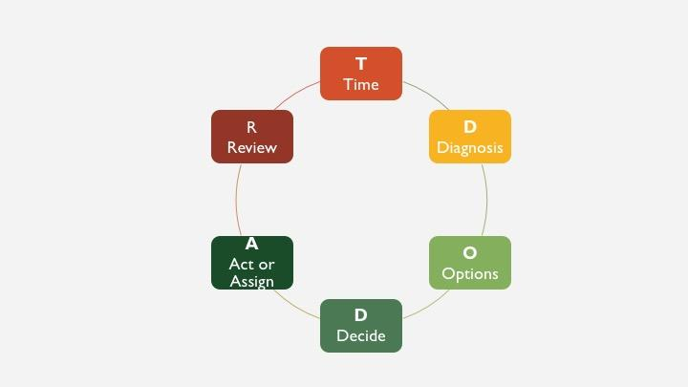

When cancer patients talk about the first moments of learning they have cancer, they often report a feeling of freefall. So, it’s fitting during the cancer decision-making process to make use of an effective method for decision-making under pressure developed by the aviation industry, which is called TDODAR. It trains pilots how to respond quickly — and wisely — in life-threatening situations, using a 6-step process: Time, Diagnosis, Options, Decide, Act, Review. It’s a continuous learning model, designed to be used as many times as is necessary to land a plane safely.

“TDODAR is particularly useful for making well-considered decisions in emergencies and in pressured situations where there's a real element of uncertainty about what to do.”

While not all cancer decisions are truly urgent, they often feel that way, and the depth of uncertainty feels shocking to most who experience it.
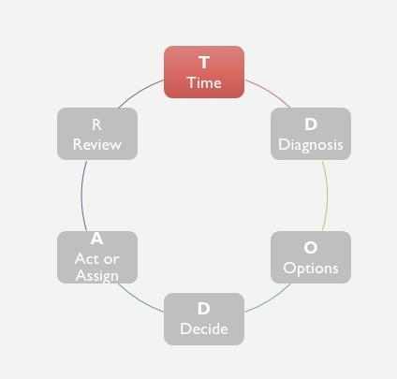 | “In our clinics, we don’t watch and wait. We use the time to actively pursue building up the health of the patient.”  Dr. Keith Block, an internationally recognized expert in integrative oncology

Time
Being told you have cancer can produce a great deal of urgency, anxiety, and pressure to make a quick decision. This may be due to a fear of the cancer spreading or it may be practical. After waiting to see a specialist, who wants to have to schedule another appointment weeks out? Yet in most cases, there is time to explore options and time to reflect before rushing into action.

Questions for your doctor
- How much time do I have to make this decision? Is there a timeline?
- What will happen if I decide to wait before starting treatment?

Questions for yourself
- What is your own sense of urgency? Does it come from an inner sense of knowing, from your medical team, or from friends and family?
- Do you feel like you have the option to take more time?
- How much information do you need to feel confident in your decision? Do you feel like you have the time to gather that information?

Tips to consider
- Shock. Many people go into shock when they receive a cancer diagnosis. Shock is not a good condition in which to make choices with lasting consequences. It is better to allow time for shock to dissipate before making medical decisions.
- Time to choose. In most cases, you have time to choose. Many people regret having been rushed into decisions they later wish they hadn’t made. Take the time you need to make an informed choice that you can support.
- Use time to start actively building back health. The length of time it takes to get a diagnosis can be frustrating. One way to manage these feelings is to regain your own sense of control by actively using this time to
  - Gather those who will help you during the process
  - Start to rebuild your health through diet, exercise, sleep/rest, and learning stress-reduction techniques.

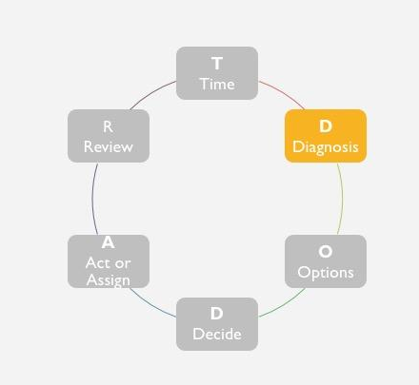

Diagnosis
An accurate diagnosis is critical to the success of what follows, and it’s worth taking the time to avoid misdiagnoses. However, this can still be a challenging task. Reading the results of diagnostic images and labs can be more art than science. Certain cancers are more difficult to detect than others. Rare diseases can be missed. To eliminate bias, pilots ask co-pilots to do the first diagnostic steps; patients would do well to have a co-pilot as well—someone to help look over the results, ask questions, and seek second opinions if necessary.

Questions for your doctor
- What is my diagnosis? What test results indicate this diagnosis?
- Are there any new diagnostic tools that might be relevant to my case?
- How confident are you in this diagnosis? Is there anything else this could be?
- What might this diagnosis mean to my quality and length of life?
- Does my case feel typical or atypical to you?

Questions for yourself
- What do you know about your condition?
- Would it be helpful to have someone go with you to appointments to record?
- What is your understanding of what this diagnosis means to you?
- Do you feel like you need a second opinion?
- Has your doctor given you a prognosis? What do you believe the prognosis is?

Tips to consider
- Write down your questions before your appointment with your doctor.
- Bring a friend. The shock of diagnosis makes it very challenging to hear all that the doctor is trying to communicate. Try recording the conversation and/or bringing a friend or family member with you to your appointment to take notes and be sure all your questions are asked.
- Where to go for diagnosis. When the cancer is still in stage I or II, and is treatable using widely-understood methods, cancer patients do just fine being diagnosed and treated at local hospitals. If the cancer is stage III (curable but requiring more advanced treatment) or IV (non-curable in the view of standard therapies), or if the cancer is rare, patients do better at regional, specialized cancer centers. Second opinions can be crucial.
- New diagnostic tools can lead to better matches with new treatments. New diagnostic tools are continually being added to augment X-rays, CT, MRI, and PET scans. These include comprehensive tumor profiling, genetic testing, virtual colonoscopies, etc. Ask your doctor which are pertinent to both your case and your treatment options.
- Understanding the diagnosis. “Many patients don’t understand what their physician tells them about their diagnosis. It’s important to be clear on the diagnosis. You want to know if the cancer can be cured or if the treatment is to ‘manage’ a cancer that cannot currently be cured. You want to know all the treatment options in either case.” Michael Lerner, founder of the Cancer Help Program
- Pathology reports are a weak link. “Reading pathology slides is known to be the weak link in cancer treatment. Different physicians may read the same slide in different ways, resulting sometimes in different diagnoses. Getting a second reading from another hospital system is optimal.” Julia Rowland, Director of the Office of Cancer Survivorship at the National Cancer Institute (NCI)
- Consider getting a second opinion on radiology reports. If your course of treatment depends on a CT report, consider getting a second reading. “The retrospective error rate among radiologic examinations is approximately 30 percent, with real-time errors in daily radiology practice averaging 3-5 percent,” according to a 2013 report.
- Doctors are highly ineffective prognosticators. “Predicting a patient's life expectancy, once an essential part of doctoring, remains a challenge for most doctors,” says Pauline Chen, M.D. Take any prognosis with a grain of salt.

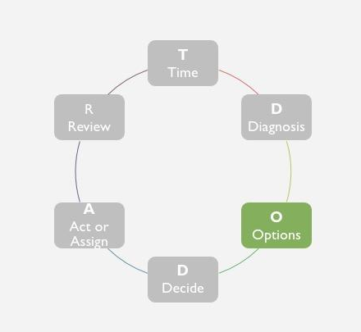

Options
Fortunately, the number of treatment options continues to expand: comprehensive tumor profiling is enabling tailored treatment plans and immunotherapies that are demonstrating results in some cancers. However, according to the Cancer Moonshot Task Force: “Routine incorporation of detailed molecular characterization of tumors to guide patient therapy from the inception of therapy has been extremely challenging across the full range of cancer types.” Chemosensitivity testing is another option, but seldom mentioned/used by oncologists. This testing requires pre-planning and sending live tissue samples to specialty labs via overnight mail.

The options available to you may be very different than those presented to your grandmother — or your friend.

Questions for your doctor
- What are your goals with this treatment?
- What options do you suggest?
- What other options are there?
- What tests are available to characterize my tumor and guide treatment choices?
- Where can I get a good second opinion?
- What happens if I don’t choose treatment?

Questions for yourself
- What are your life goals and do the medical options support them?
- What other options are you considering? (Have you considered integrative treatment options? What self-care methods would you like to try?)
- Have you gone online to do research?
- Do your options feel overwhelming, underwhelming, or empowering?

Tips to consider
- Deciding among treatment options. Treatment options may be ordered from “conservative” to “aggressive” in many cases. It’s important to take a serious inner look at what your values are, what matters to you at this time in your life, and which treatments align best with what you value.
- Where to be treated. If your cancer is common and the treatment well-established, community hospitals typically do a good job. “Higher-tier hospitals become more important as care becomes more complex,” says Dr. Otis Brawley, chief medical officer for the American Cancer Society. “Tertiary care centers also tend to be much better in taking care of the out-of-the-ordinary, unusual cancers.” Major medical center and comprehensive cancer centers are examples.
- Choosing an oncologist. It matters that your oncologist is competent and that you trust that he or she will give you the best care possible. If you don’t feel comfortable with your oncologist, it’s wise and prudent to seek until you find one you trust.
- If your cancer cannot be cured, it can often be managed for an extended period. Some of these treatments are standard and others are experimental or investigational. If you are told you are a candidate for a clinical trial of an investigational therapy, it matters that you understand everything you can about what stage trial this is and what the oncologist’s expectations are for the potential value to your health. Academic oncologists are professionally motivated to place patients in clinical trials, and so are many community oncologists, so it matters that you make an independent assessment of what kind of promise the trial holds for your health.
- The side-effects of cancer treatments vary enormously. Once you know what is being recommended, it is very wise to talk with patients who have been through the proposed treatment to see what their experience is. You can find patient forums where these questions are discussed online or in cancer support centers. Personalized medicine should include a discussion of how treatment will affect your way of life and whether equally effective alternate options exist. For instance, a professional dancer who cannot afford to have a peripheral neuropathy may be given an alternate drug in place of Taxol.
- Late-stage cancers. “Hearing your oncologist say ‘there is nothing more that we can do for you’ is undeniably traumatic and distressing. What he or she is essentially saying, however, is that there is nothing left in the conventional arsenal that can be done to eradicate the cancer. But this doesn’t necessarily mean that there is nothing else that can be done.” Keith Block, MD, Director, The Block Center

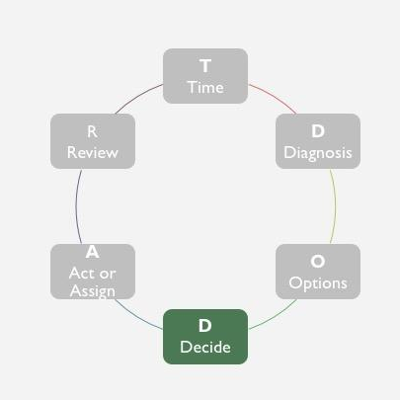 | “The objectives of shared decision-making are achieved when (1) patients are fully informed of the treatment options and the trade-offs between risks and benefits, and (2) patient values and preferences are incorporated into treatment decisions.”  Steven J. Katz, Jeffrey Belkora, Glyn Elwyn

Decide
The days of Doctor Knows Best are over; patients are an integral part of all decisions impacting them. But the complexity of the cancer world, the fact that information changes with time, and decisions involve multiple team members who aren’t in the room all at once can make the decision-making process very challenging. Yet “more informed and involved patients have better psychosocial, and in some cases physical, outcomes” so engaging fully with this process pays off.

Questions for your doctor
- If it were you, how would you make this decision and why?
- How does this decision affect my options in the future?

Questions for yourself
- How have you made the best decisions in your life? What from that process would you like to bring into this decision-making process?
- What is your experience with the medical profession? Are there any beliefs or experiences coloring your decision, for better or worse?
- How much do you trust your current medical team?
- Are you ready to decide now on your treatment options?
- Do you have a way of accessing inner wisdom?
- How does this decision make you feel? Do you believe your body will support you in this decision?

Tips to consider
- Some decisions can be made rationally; some cannot. Some cancer treatments have available evidence; others do not. Some evidence is well-researched; others reflect bias or is too limited to reach full conclusions. None of this evidence can tell you on which side of a curve you might fall. None can take into account all the conditions that have led to your cancer and all the resources and environment for your healing. So, while you may want to line up your choices in a pro-and-con table, you may find that there simply isn’t enough evidence to make a choice through logic alone. This is when bringing your whole mind to the decision can be beneficial.
- Consider your intuition as a guide once you have all the information you want about your choices. When choices are complex, intuition is a powerful way of knowing. This is your body, your life, your illness, and your healing. Don’t turn yourself over to others to make choices more than you want to. Learn how to access your own inner navigation system.

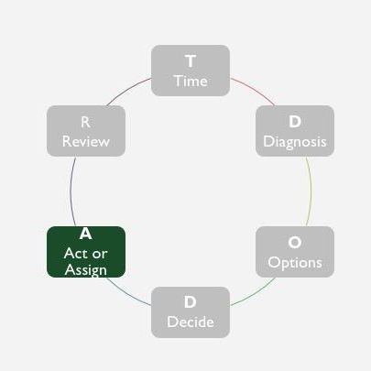

Act, or Assign
You are the leader of your health team. If you choose medical treatment, it is up to you to assign your medical treatment to the best doctor and medical facility you can. But your team is bigger than your medical team. It can include other professionals — therapist, an integrative practitioner, social worker — or non-professionals — family, friends, clergy, healing circle. Think about the full range of needs you have and try to assign as many as you can to others in amounts they can carry.

Questions for your doctor
- What is my treatment plan?
- What side-effects might I expect?
- Under what circumstances should I call you immediately or go to the ER?
- Who can I call when issues come up?
- How will you assess my progress?

Questions for yourself
- How do you feel your medical treatment is going?
- How are you managing any side-effects?
- How are you taking care of yourself?
- Do you have the support you need? Do you need to add more people to your team, whether professional or family/friends?

Tips to consider
- Build a good support team. Think about not only getting to and through treatment but your physical, emotional, mental, and spiritual needs. When people ask how they can help, ask for their help in small tasks that support those needs. If communication is a challenge for you, ask one person to serve in that role.
- The side-effects of cancer treatments can often be managed in multiple ways. In addition to pharmacological management, side-effects can be lessened through integrative treatments, such as acupuncture, or self-care strategies, such as diet and meditation.
- With some targeted therapies, be sure to check for interactions with the drugs used to treat other conditions.
- There are many integrative approaches to cancer to help you through standard treatment. Basic health-promotion strategies – eating well, moving more, managing stress, sleeping well, creating a healing environment, sharing love and support, and affirming purpose – are known to build your health. Being healthier can help you complete standard therapies and, in some cases, lower the risk of recurrence.
- Work well with your support team. Be kind to those who are helping with your healing process and be compassionate about their levels of fatigue and stress. Yet also know yourself and what is most helpful to your own healing. Be as clear as you can be about what serves and what does not.

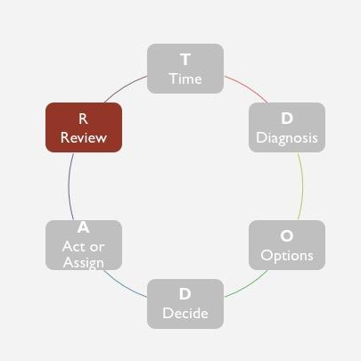

Review
The healing mindset is one of continuous learning that often requires inner listening skills, humility in the face of the unknown, resilience when a door closes, and the creativity to open a new one.

Questions for your doctor
- How often will I be monitored and how?
- [After that period] Is my plan working to cure or manage my disease?
- Is my plan working in managing my side-effects?

Questions for yourself
- Is this plan giving me the quality of life I’d like? Do I feel better?
- Are there adjustments I’d like to make?
- Is there something else I’d like to try?
- Are there other areas of healing I’d like to explore?

Tips to consider
- It’s important to know when to start a therapy. It’s also important to know when to stop. When treatments get too arduous and the potential benefit is increasingly limited, stopping therapy doesn’t mean you have given up on life. To the contrary, it can mean you will pursue your life goals by other means.
- Healing happens in more than the physical realm. Cancer often forces a life review. Patients often report that tremendous healing occurs in the emotional, mental, and spiritual realms.
- Healing can happen in every moment. Healing happens when bodies move, when relationships deepen, when beauty enters, when love abides. Look beyond your treatment to the fullness of life’s medicine cabinet for healing power and develop your intuition to pick the right healing power for this moment.

https://www.mindtools.com/pages/article/tdodar-decision-model.htm
Cindy S. Lee, Paul G. Nagy, Sallie J. Weaver, and David E. Newman-Toker, “Cognitive and System Factors Contributing to Diagnostic Errors in Radiology”, American Journal of Roentgenology 2013 201:3, 611-617
Pauline Chen, M.D. “Why Doctors Can’t Predict how Long a Patient Will Live”, New York Times, Jan 19, 2012.
Steven J. Katz, Jeffrey Belkora, Glyn Elwyn , “Shared Decision Making for Treatment of Cancer: Challenges and Opportunities”, Journal of Oncology Practice 2014 10:3, 206-20
SJ Griffin, AL Kinmonth, MW Veltman , etal: “Effect on health-related outcomes of interventions to alter the interaction between patients and practitioners: A systematic review of trials”, Annals of Family Medicine 2: 595– 608,2004 Medline

